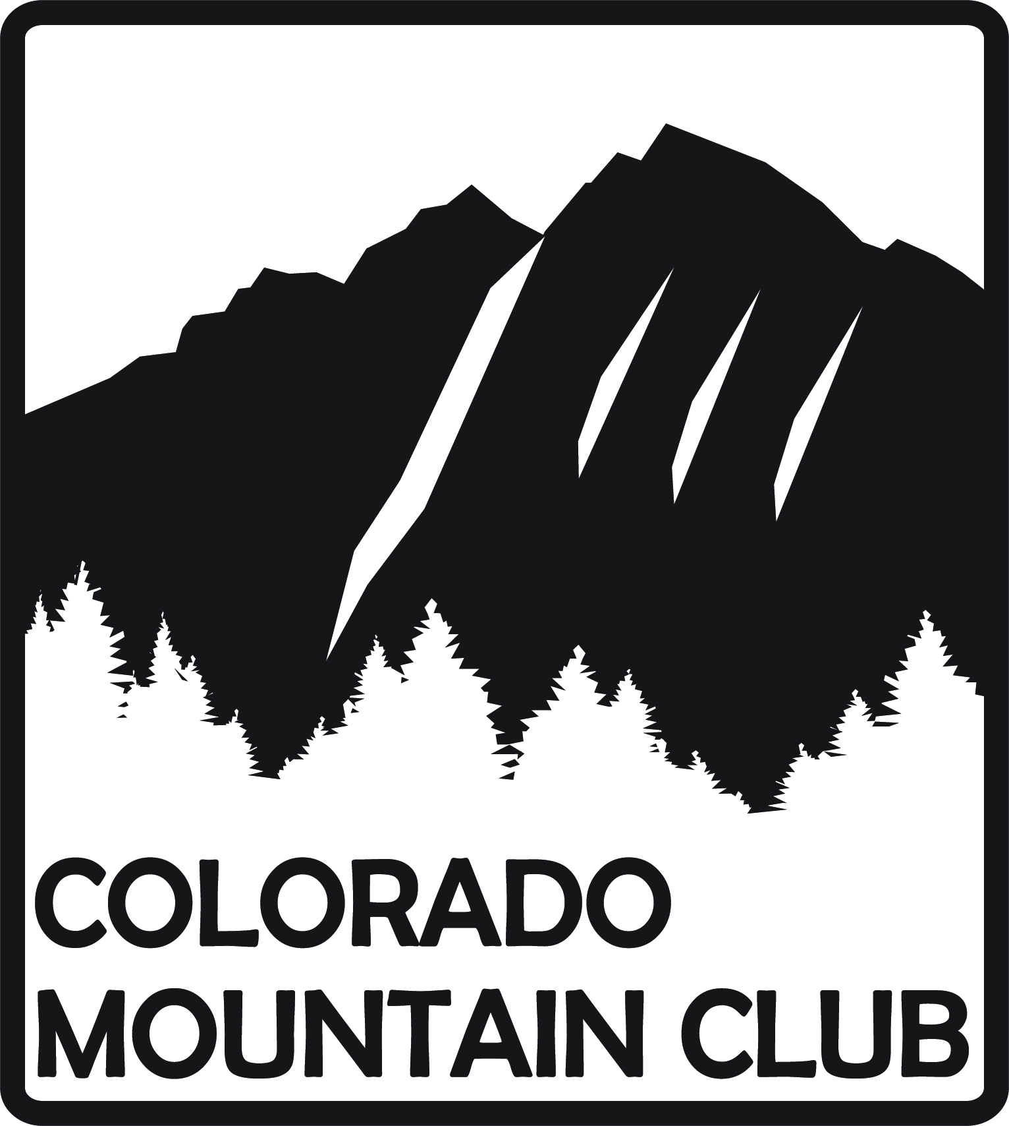 The Colorado Mountain Club 710 10th Street, Suite 200, Golden, CO 80401

WILDERNESS TREKKING SCHOOL, APPLICATION FOR WAIVER

Name |  |  | Waiver Committee Use Only
Address |  | Years or Months in CMC | Approved | Disapproved | Date
City, State, Zip |  | E-mail | By |  | Computer
Best phone number(s) to reach you (if needed) |  |  | Notification Date |  | Initials
The Wilderness Trekking School (WTS) is offered every spring and fall and consists of five mandatory class lectures and five mandatory field days. Topics include (but are not limited to) clothing, nutrition, navigation by map and compass, snow travel (including ice axe use and self-arrest), avalanche awareness, mountain weather, and basic survival skills. Training and/or equivalent experience in these skills is required to waive WTS. It is the intention of this waiver to allow those CMC members who already possess the required skills to show those competencies with a Wilderness Trekking Skill badge. CURRENT MEMBERSHIP IN THE COLORADO MOUNTAIN CLUB IS MANDATORY TO APPLY.
Please complete this form (legibly) and submit signed copy by mail or email to:

John Lindner, WTS Waiver Subcommittee Questions? Call John at 303-431-7575
11585 West 76th Way hautesnow@yahoo.com
Arvada, CO 80005-3409

Your Training, Skills and Experience

Navigation, Map & Compass
Organization/Program name | Phone | Completion Date
Description of course/program/training

Snow Field Travel, Ice Axe & Self-arrest
Organization/Program name | Phone | Completion Date
Description of course/program/training

Any other training or experience relating to this application (continue on the back, if necessary)

Rev. 10/2022 Signature(REQUIRED):______________________________________Date:____________________

